Rogues' Gallery - pages from Bill Day’s scrapbook:
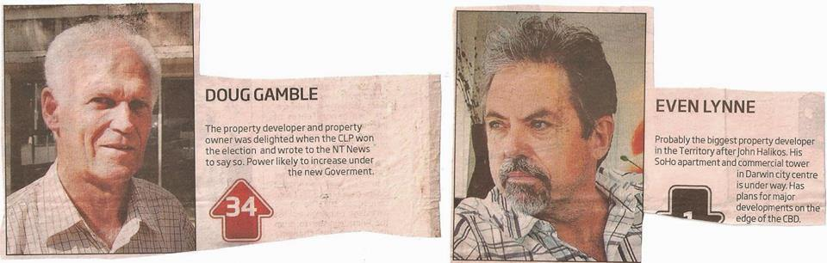Doug Gamble: In 1981 offered the Kulaluk leaseholders $78,000 to agree to the destruction of Ludmilla Creek for "East Haven" canal housing project; Even Lynne: In 2009 he signed a "Non Lapsing Caveat" between Gwelo Investments and the leaseholders over all the mangrove areas and land on seaward side of Dick Ward Drive for Gwelo's "Arafura Harbour" canal housing and marina and a company by that name paid out $1.17mil to the leaseholders for the privilege, but got nothing for it;
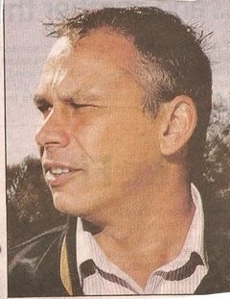
Dave Tollner and Adam Giles: In 2015 signed a toothless "Memorandum of Understanding" with the leaseholders which remains secret to this day;
In 2014 as Minister for Lands and Planning, Peter Chandler rezoned land down from Totem Road on the lease in a cyclone storm surge zone for Ernie Chin's Dragon Lady Pty Ltd. Previous ministers (Gerry McCarthy) had refused the application on conservation and planning grounds;
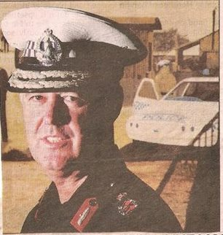
John Roberts: need I say more; John Halikos: with Ernie Chin as negotiator (according to news reports) and with Planit Consulting, Halikos's company made a secret agreement with the leaseholders to dump a mountain of construction waste on the lease beside the Minmarama Community. Even Dave Tollner described the dump as "unlawful".

Absent (some say he has left town) - Ernie Chin: Was a director of Alan Jape’s Citiland Pty Ltd who have a caveat over land between Dick Ward Drive and Bagot Road on the Kulaluk Lease Area. Claims the Cullen Bay development with Even Lynne of Gwelo Investments /Arafura Harbour Pty Ltd is his greatest achievement. Chin also “brokered” the secret deal between John Halikos and the Gwalwa Daraniki Association Inc for Halikos to dump a mountain of construction waste on the Kulaluk lease next to the Minmarama community. Was good mates with Dave Tollner and Adam Giles. Worked closely with Michael Chin the Gwalwa Daraniki Association lawyer who signed off on the amended 2006 constitution limiting membership to a minimum of five belonging to an undefined clan and their spouses who have lived on the lease for no less than 12 months. Ernie Chin’s Dragon Lady Pty Ltd applied successfully to the Development Consent Authority to rezone land adjacent to an Aboriginal burial ground within the primary storm surge zone on the Kulaluk lease. Chin cleared the land in May 2014 despite Larrakia protests. The Totem Road block has remained overgrown with weeds for the past four years.

